Gem Industries, Inc.

State Certified Minority Enterprise
100% Women Owned/SDB
370 Cox Road Cocoa, FL 32926
321-631-3977 Office 321-631-8464 Fax
www.gemindustriesincorporated.com

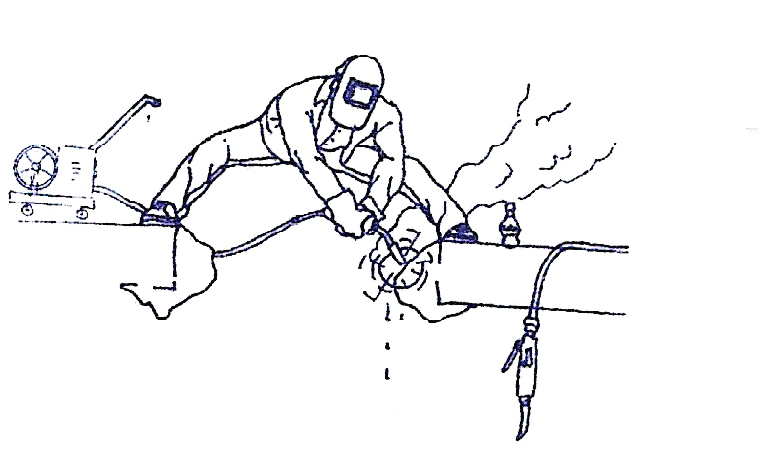
Capabilities Statement

GEM Industries has 35 years experience in the Miscellaneous and Structural Metals Fabrication industry. We specialize in Miscellaneous metals such as Stairs, Landings, Platforms, Handrail, Cable Railing, Glass Railing, Ladders, Canopy Structures, Ornamental, Maintenance Fabrication, Shearing, Braking, Forming, along with Structural projects of Columns, Beams, Joist & Deck up to 75 tons, Field Crews for Erection and Installation, Certified Welding, Certified Welding Inspection and Weld Certification. We can service all of your metal fabrication needs the above examples are just to name a few.

- D & B #363306528
- NAICS CODES: 332312 332999 332323 331210
- CAGE CODE: 5UYF5
- CERTIFICATIONS: WOMAN OWNED/SDB/STATE CERTIFIED MINORITY ENTERPRISE/
- GOAA M/WBE CERTIFIED
- GSA SCHEDULE: IN PROCESS
- REGISTERED: SAM (Formally CCR), ORCA, FED BIZ OPS
- PAYMENTS: CASH, CHECK, VISA, MASTERCARD, AND GOVERNMENT “P” CARD

We are based in Cocoa, Florida about 30 minutes from Kennedy Space Center, FL. We cover the lower Southeastern United States but will ship or transport anywhere.

Projects:
Vehicle Assembly Building, Steel LLC - KSC, FL | Universal City Walk Project, HP - Orlando, FL
Window/Louver Refurb of LCC - KSC, FL | ONC - KSC, FL
Hangar AF - CCAFS, FL | Suncoast Community High - Riviera Beach, FL
Reutilization, Recycle, and Market Facility - KSC, FL | Pahokee Middle School - Pahokee, FL
Hangar AE - CCAFS, FL | Maitland/Dommerich Middle School - Maitland, FL
TEL 4/COMMAND Towers - CCAFS, FL | Darton College - Albany, GA
Eastern Processing Facility – CCAFS, FL  South Terminal C Phase 1 Landslide-Orlando, FL- Banker Steel | Central Campus Headquarters, HP – KSC, FL  Arthrex Office Building-Naples, FL- Cives Steel

Customers: Delaware North, Hensel Phelps, Turner Construction, City of Altamonte Springs, Brevard County, City of Cocoa, Space Coast Launch Service, Disney, Universal Studios, Anheuser Busch/Sea World, General Contractors etc.

GEM INDUSTRIES INC is a professional fabricator, dedicated to providing quality projects at competitive rates, with an emphasis of on time delivery.

Ann-Jeanette Miner, President 321-302-8985 (c) Aaron Cottle, Operations Mgr 321-212-8566 (c)
370 Cox Rd. Cocoa, FL 32926 (321) 631-3977 (office) (321) 631-8464 (fax)
www.gemindustriesincorporated.com

